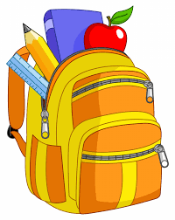 **Second Grade Supply List**

Mask (personalize when possible)

2 boxes of sharpened #2 pencils

1 box of crayons

1 highlighter marker

1 8oz. bottle of glue

scissors

1 eraser

6 marble composition notebooks (different colors if possible)

5 pocket folders

1 pencil case (large enough to fit all student supplies)

1 package loose-leaf paper

1 paper towel roll

2 boxes of tissues

1 large bottle of hand sanitizer

1 container of disinfecting wipes

**Suggested Supplies:**

1 laptop for remote/distance learning

**PLEASE WRITE YOUR CHILD’S NAME ON ALL SUPPLIES.**